**INTI International College Penang School of Engineering and Technology**

**3+0 Bachelor of Science (Hons) in Computer Science, in collaboration with Coventry University, UK**

**3+0 Bachelor of Science (Hons) in Computing, in collaboration with Coventry University, UK**

**Coursework cover sheet**

## **Section A - To be completed by the student**

|  |  |
| --- | --- |
| Full Name: **TAN YI JIA** | |
| CU Student ID Number: **12672752** | |
| Semester: **2** | |
| Session:  **April 2022** | |
| Lecturer:  **Nadhrah Abdul Hadi (nadhrah.abdulhadi@newinti.edu.my)** | |
| Module Code and Title:  **4067CEM Software Design** | |
| Assignment No. / Title:  **Continuous Assessment** | % of Module Mark:  **50** |
| Hand out Date:  **22nd April 2022** | Due Date:  **Task 1: 13 May 2022, by 11.59pm**  **Task 2: 1 July 2022, by 11.59pm**  **Task 3: 17 June 2022, by 11.59pm.**  **Task 4: 17 June 2022, by 11.59pm.**  **Task 5: 17 June 2022, by 11.59pm.** |
| Penalties: No late work will be accepted. If you are unable to submit coursework on time due to extenuating circumstances, you may be eligible for an extension. Please consult the lecturer. | |
| Declaration: I/we the undersigned confirm that I/we have read and agree to abide by the University regulations on plagiarism and cheating and Faculty coursework policies and procedures. I/we confirm that this piece of work is my/our own. I/we consent to appropriate storage of our work for plagiarism checking.  Signature(s): Yi Jia Tan | |

## **Section B - To be completed by the module leader**

|  |  |  |
| --- | --- | --- |
| Intended learning outcomes assessed by this work:  1. Understand and apply appropriate concepts, tools and techniques to each stage of the software development  2. Understand and apply design patterns to software components in developing new software  3. Demonstrate an understanding of project planning and working to agreed deadlines, along with professional, interpersonal skills and effective communication required for software production  5. Demonstrate an awareness of, and ability to apply, social, professional, legal and ethical standards as documented in relevant laws and professional codes of conduct such as that of the Malaysian National Computer Confederation. | | |
| Marking scheme | Max | Mark |
| 1. User Story Mapping 2. Setting up a GitHub Repository 3. Creating a Class diagram and design pattern selection 4. Creating a Prototype User Interface and Usability Testing 5. Discuss the ethical issue related to the software | 20  10  30  20  20 |  |
| Total | 100 |  |

# **Task 1 – User Story Mapping**

User: Tunku Abdul Rahman University College’s Students

Vision:

A college events system is developed to encourage students actively join in college events and connect them in the community through the events. As the times progress and social development, people nowadays are becoming less communicate with other because of increased in use of electronic gadgets. Thus, they also become egotistic and materialistic person because influenced by the social medias. Therefore, this college events system help in connect the students in the community that can bring positive influences and motivations to them.

# **User Story Mapping**

An online whiteboard platform ‘Miro’ is used to conduct the user story mapping for the college events system.

Figure 1 shows the user story mapping of Tunku Abdul Rahman University College Events System for Students.

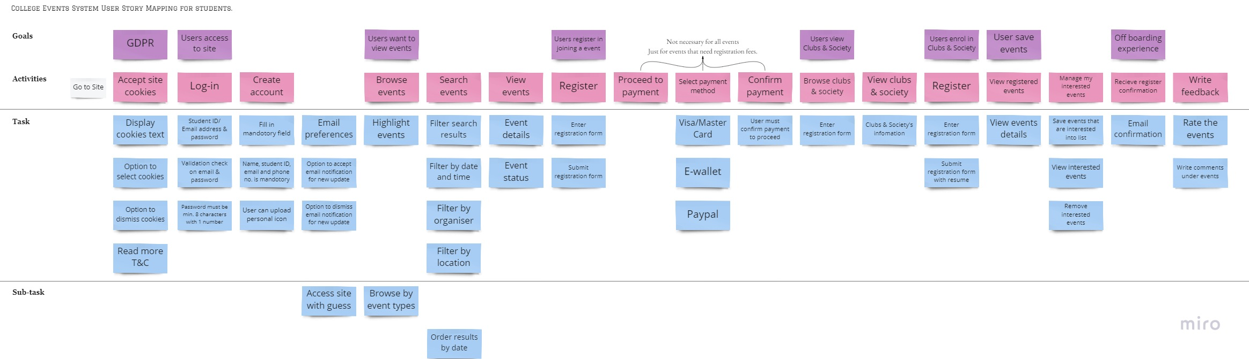

Figure : User story Mapping

Based on the Figure 1, the backlog can be break down into 8 main goals which is General Data Protection Regulation (GDPR), Users access to site, view events, register in joining an event, view clubs and society, enrol in clubs and society, save events and off boarding experience.

Firstly, a user who like to enrol in clubs and societies or register in events need to go to the site. User should read the General Data Protection Regulation (GDPR) and accept the site cookies then only can access to the site. Users may access the site with guess to view the events and clubs but the users are required to log in or sign up to own account to register in events and enrol in clubs and society. For the user who want to enrol in the clubs and society are needed to enter and submit the registration form while the user who want to interview for the committees would submit their resume together with the registration form.

Next, for the user who want to register in joining the events are also needed to enter and submit the registration form. However, some events may require to pay the registration fee or other processing fees. Thus, the payment feature is added into the system to let admin easier to receive the payment but the feature is not applicable for all the events. For this feature, users are needed to select the payment method and confirm the payment to successfully register in the events.

The offboarding experiences is the process after users had registered in events or clubs and society and participated in the events. The user will get an email notification to confirm that he/she is successfully registered or enrolled. Besides, users can write feedback to admin or organiser after participated the events about their experiences of the events by give rating or write comments to the events.

## **User Feedback**

20 user’s feedback from college students are collected through Google Form by survey. The survey questions and responses as shown in below.

Question 1

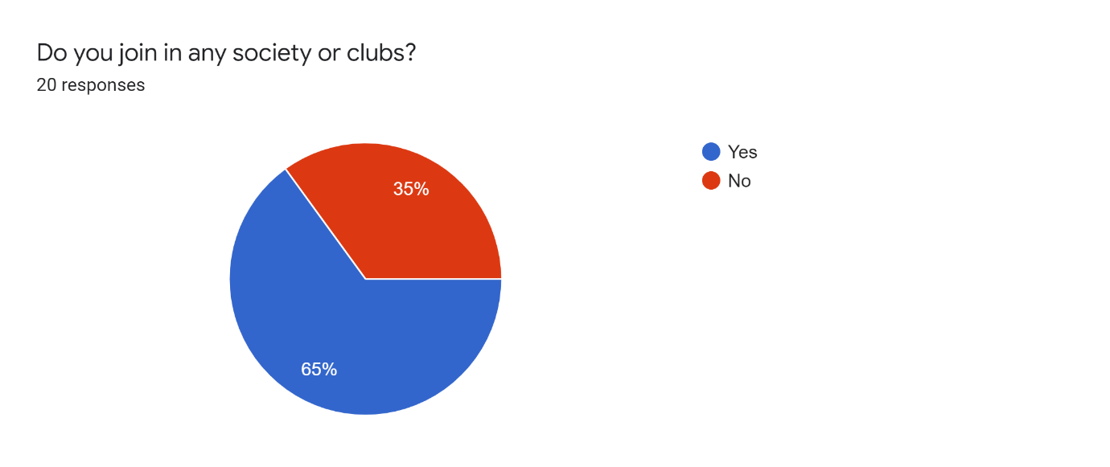

Question 2

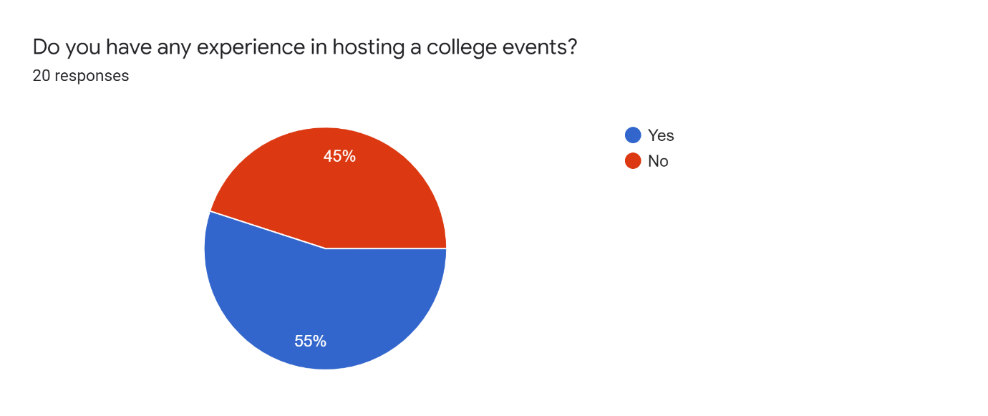

Question 3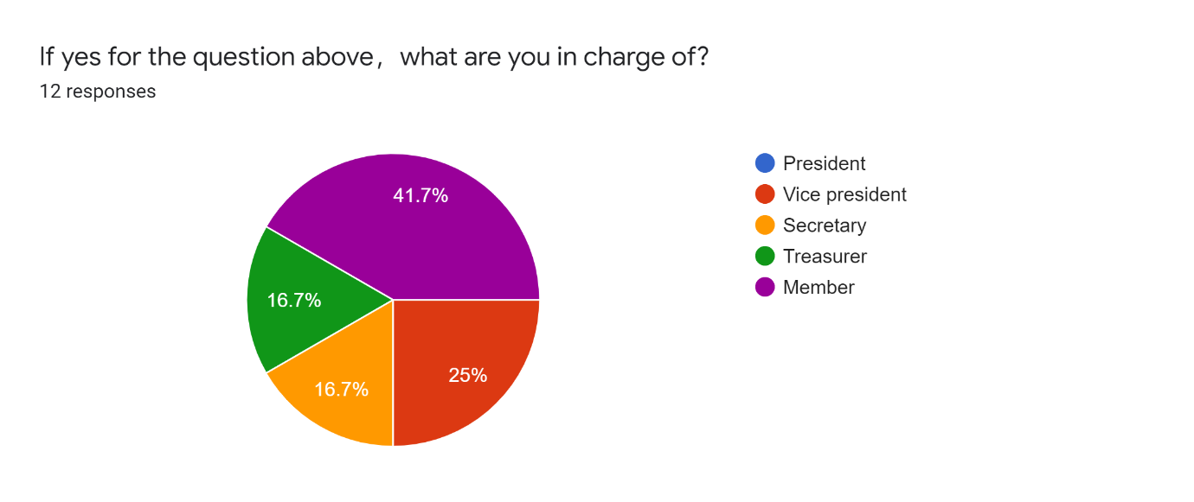

Question 4

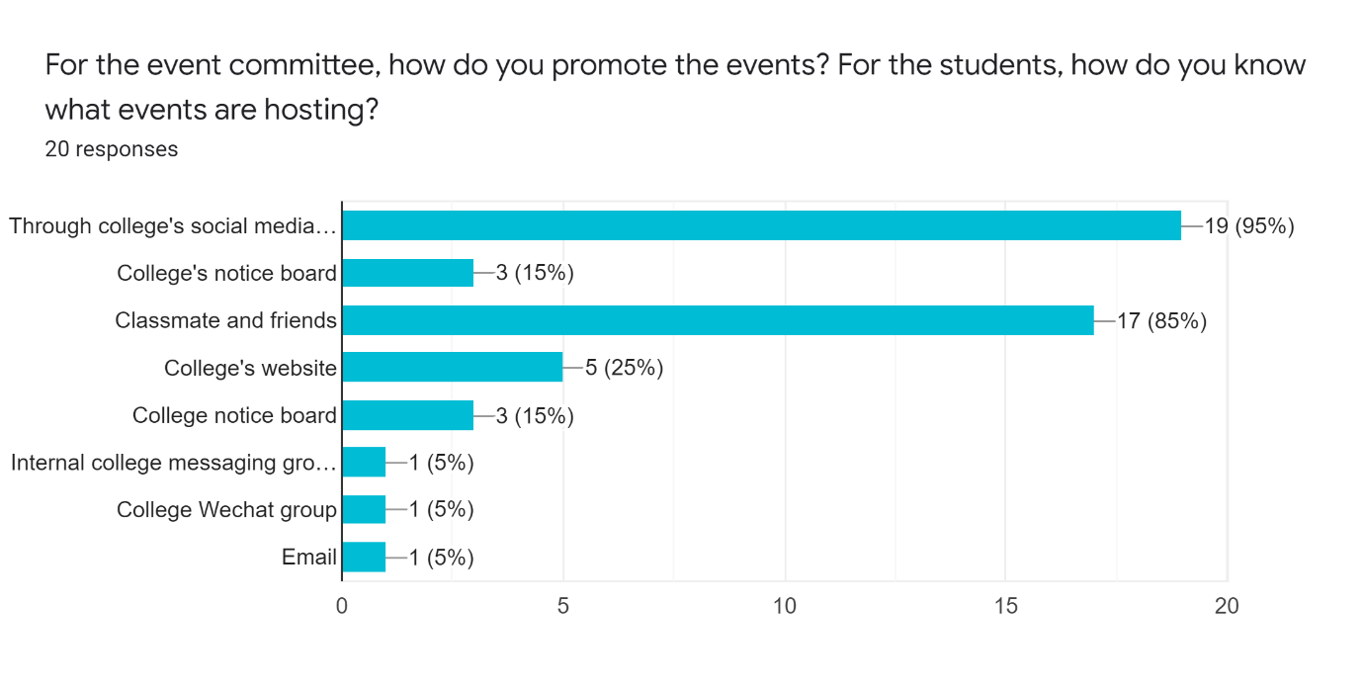

Question 5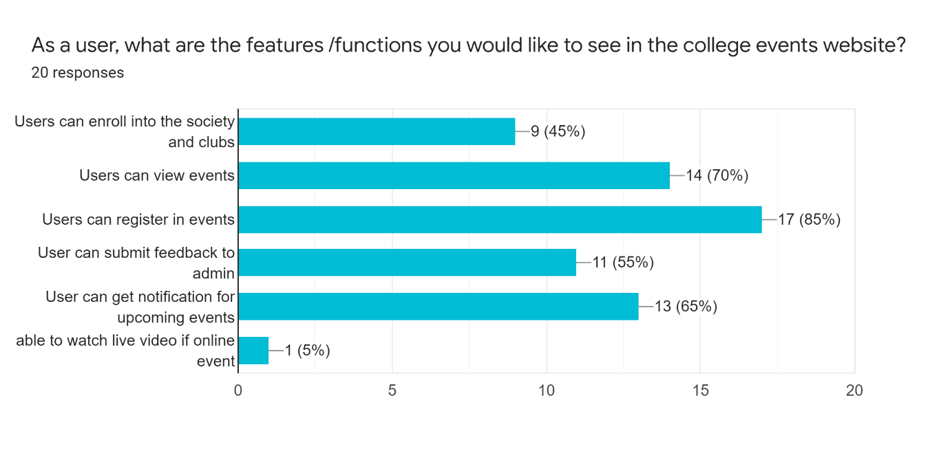

Question 6

Why you hope to see the features in the system? [As <User>, I want to <Series of activities> so that <Goal>.]

* As an event organiser, I want the system to allow new students enrolled into clubs and societies so that the registration flow for clubs and societies would not be so tedious and troublesome for both the committees and the students.
* As an event organiser, I want to restrict the unqualified student to register the particular event so it may help me to pick up the most suitable student to join our event instead of gain soft skill marks.
* As an event committee member, I want to view the whole planning of event so that I can know what is the progress stage is it.
* As an event organiser, I want to check the feedback from participants so I can know how they feel for the events.
* As a committee, I want to check the schedule so that I can check whether when is the event going to be organised.
* As an student，I want to know what event is going on and how I registered it if I am interested in so that it can ease my mind and I won’t be in a blurred situation.
* As a student, I want to always keep track on the ongoing events so that I could be able to join in time whenever the event I am interested to.
* As a student, I want to view the events so that I can have a better understanding about the details of the events and consider whether to join or not.
* As a student, I want to view a detailed information of the events so I can decide whether I should participate or not.
* As a participant, I want to get notifications for upcoming events so that I can plan my scheduled ahead of time.
* As a student, I want to get notice from the websites so that I get reminded of the activities.
* As a student, I want to get notification for events so that I won't miss anything I am interested in.
* As a student, I want to know detail about the events so that I can know is that I am interested.
* As a student, I want to see upcoming events so that I know what activities I can participate in.
* As a user, I would like to view events because it is easier for every student inside the college to know every kind of event there are.
* As a user, I want to view the event so I can know more about the event.
* As a student, I want to view the events in the system so I can know the update of events and no need to ask other people about the event details.
* As a participant, I want to be able to view and register upcoming events in a same system rather than copy and paste the registration link from platforms like WeChat into Google Chrome which could be troublesome at times.
* As an admin, I want to add the features of view and register in events in the system because the system can help to get wider awareness and better publicity.